CP Science 9
Climate Types Worksheet

Read the information below and answer the questions on a separate piece of paper.

The Steppe Climate
The steppe or semiarid climate zone is located in prairies and grasslands. Steppes are often found surrounding desert areas. Annual rainfall is light, somewhere between the desert and more humid climates. Specific characteristics of steppes depend on their latitude and whether they are located near mountains and oceans.

Part 1
The graphs below show one way to summarize basic climate information. The line shows how the temperature changes over the year. The bar graphs show the monthly precipitation. Both places graphed are classified as steppes.

Use the information in the graphs to answer the questions.
- Calculate for each location:
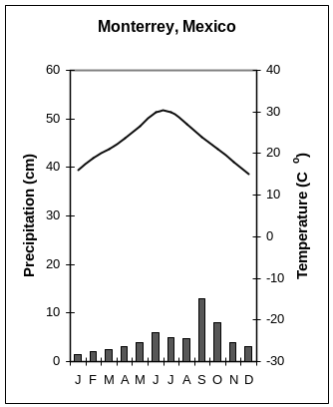
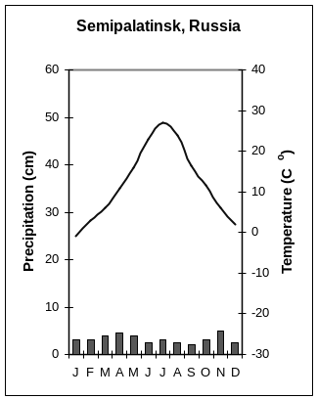
a)the average yearly temperature
b)the temperature range
c)the total annual rainfall
Since the average yearly rainfall is about the same, how is the rainfall distribution different between the two locations?

What does the graph tell you about the temperature range in Monterrey?

What does the graph tell you about the temperature range in Semipalatinsk?

Which location apparently has the higher average temperature?

Write a paragraph comparing the climates in the two places.

Part 2
Trace one of the graphs above without the data and make a graph on your paper using the data from Pueblo, Colorado, below. Use the information on the graphs to answer the questions.

Rainfall: January 1 cm, February 2 cm, March 2.5 cm, April 4 cm, May 4 cm, June 3.5 cm, July 5 cm, August 4.5 cm, September 3 cm, October 2 cm, November 1 cm, December 1.5 cm

Temperature in degrees Celsius: January 0 , February 0 , March 5 , April 10 , May 15 , June 20 , July 24 , August 24 , September 18 , October 11 , November 5 , December 0

When is the rainy season in Pueblo, Colorado?

Which of the three locations has the wettest summers?

Compare the climate in Pueblo to the climate in Monterrey.

