CP Science 9: Test Review (8.1-8.4, 11.1-11.3)

- Arrange layers of the earth in the right order, including the Moho.
- Where does earthquake shadow zone occur and why?
- Where do earthquakes occur? List the three types of waves produced from earthquakes. Which one is fastest/slowest?
- What is a seismograph? How can we locate an earthquake epicenter?
- Use a travel-time graph to determine the time it takes for P-wave to travel 1200 km. If the S-wave travels to a seismograph station 4 minutes 20 seconds later than the P-wave, how far is the earthquake? If the S-wave of an Earthquake 1500 km away arrives at 10:10 am, when did the earthquake occur?
- What does a Richter scale measure? How much greater is a Richter scale 6 earthquake than a Richter scale 3 earthquake in magnitude?
- What is liquefaction? How does a tsunami operate?
- What is mountain? List the types of stress involved in mountain formation.
- How to identify a hanging wall versus a footwall? Name the four types of faults.
- List the three types of mountains.

At least ______ seismograph stations are needed to locate an earthquake.
two three four five
An earthquake of magnitude 8 releases how much more energy then an earthquake of magnitude 4?
twice as much half as much 10 000 times 100 000 times
In the diagram on the right A is a
horst graben thrust fault reverse fault
In the diagram on the right, B is caused by
compression tension shear anticline

In the diagram above, C is a
subduction boundary reverse fault thrust fault strike-slip fault
16. Seismic waves move outward from the
a. focus b. epicenter c. Moho discontinuity d. continental margin
17. _______ waves arrive at a seismograph first.
a. surface b. Rayleigh c. primary d. secondary
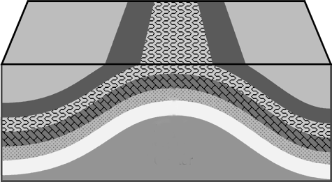
18. In the diagram to the right, the fold center is a(n)
a. horst b. graben c. syncline d. anticline
19. In the diagram to the right, the feature is caused by
a. S-waves b. p-waves c. faulting d. folding
20. In the diagram to the right, the feature would be caused by
a. tension b. compression c. shear d. strike-slip
21. Complete the graphic organizer below by filling in the process that created each type of mountain and an example of each.
Folded mountain | Volcanic mountain
Dome mountain | Fault-block mountain

