CP Science 9
Locating an Earthquake

PURPOSE: Compute the distance of three different seismograph stations from a strong earthquake. Use the information to determine the location of the earthquake.

MATERIALS:
drawing compass
metric ruler

PROCEDURE:
Convert the P-wave arrival times to total seconds and record on the DATA table. Compute the distance of each station from the earthquake center. The P-wave travels at a speed of 6 kilometers per second. Record the distances on the DATA table under Epicenter Distance.

The scale of the map on the back is 1 cm = 325 km. Use this scale to convert kilometers to centimeters and record under Map Distance.

On the map, use a compass draw an arc from each station using the map distance as the radius of the circle.

Locate the epicenter of the earthquake. It is the point at which all arcs intersect (cross).

Once you have located the epicenter, measure and calculate the
P-wave arrival time in Newport, WA. and McMinnville, TN.
DATA:

Table 1
Station | P-wave arrival time (in minutes) | P-wave arrival time (in total seconds) | Epicenter Distance (in kilometers) | Map Distance (in centimeters)
Rockville, MD | 6 min, 35 sec
Newport, WA
Tucson, AZ | 3 min, 47 sec
Rapid City, SD | 4 min, 14 sec
McMinnville, TN

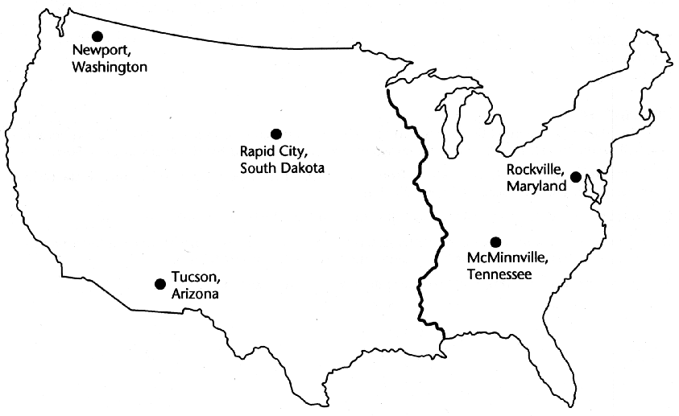

DATA ANALYSIS:
1. In what state did the earthquake occur?
2. Near what major city did the earthquake occur?
3. Using the figure box on text page 225, if a seismograph were located 1600 km from the earthquake's focus, how long would it take the P-wave to travel that distance?
4. If the S-wave travels at half the the speed of the P-wave, how long would it take for the S-waves to arrive at each of the five locations?
5. Using the figure box on text page 225, how far away from each station is an earthquake, if four different seismograph stations record the difference between the arrival time of the two waves at
a)2.0 min b)2.8 min c)3.9 min d)4.5 min

