CP Science 9
World Map Exercise

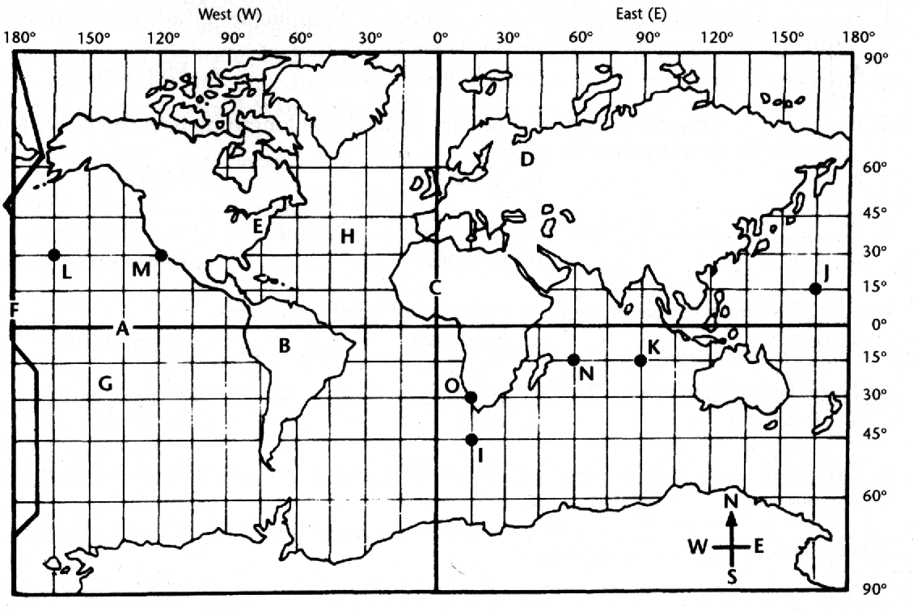
Number a sheet of paper 1-14. Study the map. Write the letter of each map feature or location on numbers 1-10.

1. equator
2. prime meridian
3. International Date Line
4. 90° east longitude
5. 15° north latitude
6. 45° south latitude
7. 165° west longitude
8. 15° south latitude, 60° east longitude
9. 30° north latitude, 120° west longitude
10. 30° south latitude, 15° east longitude

The map shows longitude in the 15 degree increments that are approximate to the time zones. Use the lines of longitude to estimate the time for the following places. Answer the following questions.

11. You're at point B on the map. It's 7:00 A.M. What time would it be at point E?
12. You're at point H on the map. It's 5:00 P.M. What time would it be at point G?
13. You're at point H on the map. It's 7:00 P.M. What time would it be at point D?
14. You're at point J and you travel eastward to point L. Do you lose or gain a day?

