CP Science 9
Unit 3 Worksheet

This unit will cover chapters 9 and 10.1. Please remember to answer all questions on a separate sheet of paper, restating the question in your answer.

Section 9.1 Continental Drift

- What is Wegener’s the theory of continental drift?
- What is Pangaea, and what does Pangaea mean?
- List and describe, in detail, the four major pieces of evidence that support the theory of continental drift.
- Why is it that Wegener’s theory was not widely accepted?

Section 9.2 Plate Tectonics

- Of what is the lithosphere made?
- What layer will you find immediately below the lithosphere?
- What are (tectonic) plates?
- How quickly do tectonic plates move, on average?
- List the three main types of plate boundaries.

Section 9.3 Actions at Plate Boundaries

- What is a divergent boundary, and where are you most likely to find it?
- Is a divergent boundary considered constructive or destructive, and why?
- What is seafloor spreading? At which boundary type will it occur?
- What happens at a continental rift?
- What is a convergent boundary?

- Copy and fill in the following table:
 | How does each plate respond? | What geologic feature is created? | Provide an example of this boundary type
Oceanic-
Continental
Oceanic-
Oceanic
Continental-
Continental

- What is a transform fault boundary?
- Name the transform boundary that cuts through continental crust (that is very close to us).

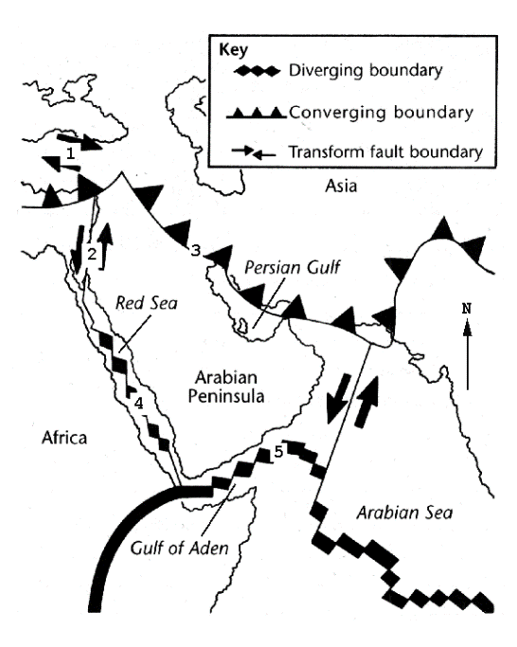
Use the map to the right for the following 3 questions
- What is happening at #2? Is land being created or destroyed?
- Is the Arabian Sea getting larger or smaller? Why?
- What is happening at point 4?

Section 9.4 Testing Plate tectonics

- Paleomagnetism is the study of changes in Earth’s magnetic field (yes, it has changed, the North Pole hasn’t always been north). How do scientists know this, where do they see this information recorded?
- How have scientists used paleomagnetism to prove that the theory of plate tectonics is correct?
- Compare the maps on pages 226 and 256-257. One shows earthquakes and the other shows plate boundaries. Make a comparison of these two features.
- Scientists have drilled into the ocean floor to take samples and calculate the age of rock. They found, as predicted, that the age of the ocean floor changes as you move from the mid ocean ridge toward the coast of the continents. Where is the rock the youngest and where is it oldest

Section 9.5 Mechanisms of Plate Motion

- What is the mechanism thought to cause plate motion?
- Ultimately, what is it that causes the convection in the mantle that results in the movement of the tectonic plates?

Section 10.1 The Nature of Volcanic Eruptions

- What is a volcano?
- What are the two factors that determine whether a volcano erupts violently or quietly?
- If magma contains a large amount of silica, what will this do to its viscosity? What sort of eruption with this result in?
- Which type of magma would result in a more explosive eruption, one with a large amount of dissolved gases, or a small amount of dissolved gases?
- What are the materials that may be ejected during a volcanic eruption?
- What is a caldera and how does it form?
- Copy and fill in the following table:
 | Of what materials  is it made? | What is its relative size and shape? | Where are you likely to find this type of volcano?  Or give an example.
Shield
Volcano
Cinder
Cone
Composite Cone

