CP Science 9: Earth Science Unit 3
Test Review (p11-12, chapters 9 and 10.1&10.3, p291-292, p298-299)

Things to know:
Study the figures on pp255 and the examples from the chapter.~ *Review your CA Plate Tectonics and Seafloor Spreading Labs ~ ‘Kinds of Volcanic Eruption’ - reading,~ and notes from both the videos.~ Read pages 281-283 for silica, gas, viscosity and type of eruption ~ Read about the formation and breakup of Pangaea and how its related to continental drift.

Answer the Following Questions:
- Lines of_________ run parallel to the Equator. Whereas, lines of _________ run parallel to the Prime Meridian.
- How are time zones created and how large are they?
  - How does the time in one zone relate to other zones?
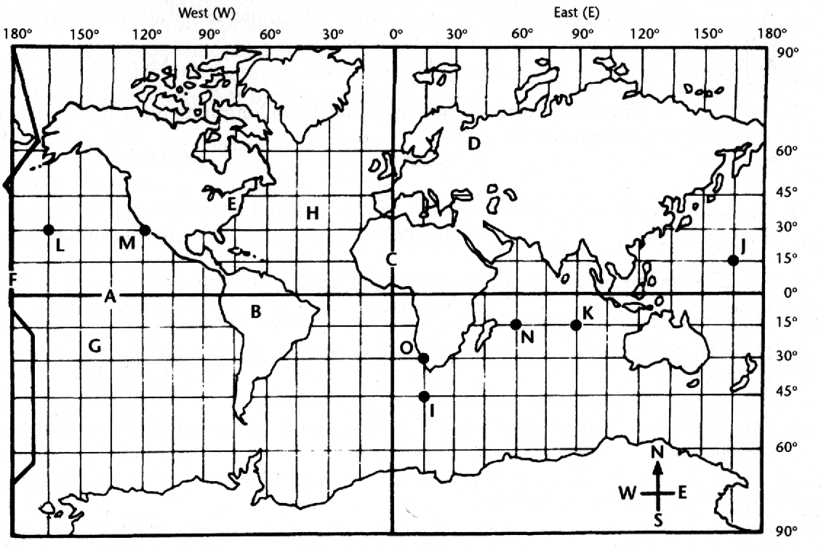

- On the map on the left locate and label the prime meridian, International Date Line, the equator, lines of latitude, lines of longitude, and time intervals.
  - Which line(s) separates the Northern from Southern Hemispheres?
  - Which line(s) separates the Eastern and Western Hemispheres?
- How many degrees is equal to one hour?
- If it is 6 pm at point N, what time is it at point K?
- If it is 3 am at point M, what time is it at point L?

- Who had the original idea of continental drift and what were his four lines of evidence?
  - Why did scientists not accept this idea?
- What is plate tectonics and what is the evidence for it.
- Where do earthquakes and volcanoes mostly occur?
- What are the three types of plate boundaries and what are the features found there?
- What are the three types of convergent boundaries and why are they different?
- What are the three believed causes of plate movement (p 269)?
- Review how volcanoes form at divergent and convergent boundaries and at hot spots.
- What are the factors that affect eruptions? Explain how each impacts an eruption.
- Know the origin of magma and the conditions that result in there formation of magma.
- What are the types of magma and what makes them flow differently as lava?

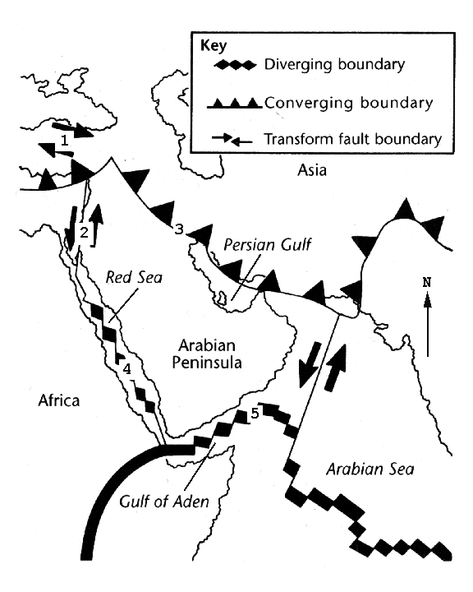
- Using the diagram above to the right identify the boundaries as divergent, convergent or transform.
  - Determine how each structure is moving in relation to the others structures.
  - Is the Red Sea getting larger or smaller?
  - Is the Persian Gulf getting larger or smaller?
Match the Following Volcanic Forms & Material

- Caldera

- Crater
- Vent
- Pyroclastic material
- Volcano
- Shield volcano
- Lava Plateau
- Cinder cone
- Aa
- Pahoehoe
- Composite cone
- Volcanic pipe

  - an opening in the surface of the Earth through which molten rock and gases are released
  - a large depression typically caused by collapse or ejection of the summit area of a volcano
  - Fluid basaltic lava extruded from crustal fractures called fissures.
  - the conduit within a volcano that feeds magma from the chamber to the surface
  - the volcanic rock ejected during an eruption, including ash, bombs, and blocks
  - type of flowing basaltic lava that resembles twisted braids or ropes and is common in Hawaii
  - a small volcano built primarily of pyroclastic material ejected from a single vent
  - type of lava that has a surface of rough, jagged blocks
  - a broad, gently sloping volcano built from fluid basaltic lava
  - a mountain formed of lava and/or pyroclastic material
  - the depression at the summit of a volcano or that which was formed by a meteorite impact
  - a volcano composed of both lava flows and pyroclastic material (produces the most violent eruptions)

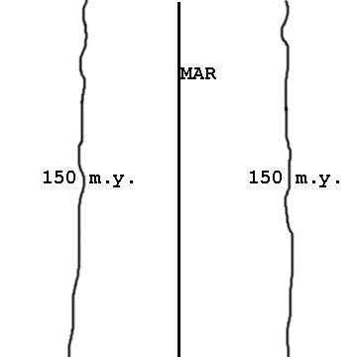
- In the figure to the left MAR is the mid-Atlantic ridge and the lines on either side represent strips of ocean floor where the rocks are 150 million years old. Use a metric ruler and calculator the average distance, the half rate in km/m.y. and spreading rate in cm/y. The map scale is: 1 cm = 594 km

