CP Earth Science 9
SEA FLOOR SPREADING IN THE ATLANTIC OCEAN

Sea floor spreading is one component of the theory of plate tectonics. According to this concept, at mid-ocean ridges in many of the world's oceans, new crustal rock is added to the edges of plates on either side of the mid-ocean ridge. The mid-ocean ridge in the middle of the Atlantic Ocean is known as the Mid-Atlantic Ridge (MAR). At the MAR, new sea floor rock (basalt) is added to the edges of the North American, South American, Eurasian, and African plates. The result of the addition of new sea floor rock is that the Atlantic Ocean between these continents is widening. North and South America move farther away from Eurasia and Africa each year.

The youngest sea floor rocks are found in the middle of the ocean because that is where new sea floor is added. As you move away from the MAR, the sea floor rocks become increasingly older. The oldest sea floor (the first Atlantic sea floor formed that is still preserved) is found closest to the continents. One way that geologists can recognize the strips of sea floor basalt created at, and later moved away from, the MAR is by collecting rocks from the sea floor to determine their magnetic properties and ages.

A strip map of a portion of the North Atlantic region is provided. The thin line that approximately parallels the easily recognized coastline is the continental shelf edge. The continental shelf best defines the true edge of the sections of continental crust, which at some time in the past were joined together. The BOLD line labeled "0" and located about half way between North America and Africa is the Mid-Atlantic Ridge (MAR) where new sea floor forms. On either side of the MAR are strips of sea floor basalt labeled with their ages in millions of years (m.y.). For example, 55 million years ago, the strips of sea floor labeled "55" were formed at the MAR. Over the past 55 m.y., these strips of rock have cooled and been moved away from the ridge where they were formed.

PURPOSE: Study sea floor spreading

MATERIALS:
metric ruler
calculator

PROCEDURE:
1. Copy the DATA tables on a sheet of paper.
2. Read the map and description on the bottom of page 2. Measure the distance between points A and B in cm to determine the map scale by dividing km by cm. Record the scale on the data table.
3. For each strip on the map measure the distance along a perpendicular line from the MAR (0) west to the strip. Record the age of the strip and the distance on the DATA table.
4. For each strip calculate and record the distance from the MAR in kilometers (distance measured times map scale).
5. For each strip, using the age of the rock and its distance from the MAR, calculate and record the half-rate of sea floor spreading, the velocity (v = distance/time = km/M.y.) at which this strip of rock has spread away from the MAR.
6. Calculate and record the total rate (velocity) of sea floor spreading (half-rate x 2).
7. Calculate and record the average rate of sea floor spreading.
8. Convert and record the sea floor spreading rate from km/m.y. into cm/y.

DATA:
Map Scale | 1 cm = km

Strip Age | Distance (cm) | Distance (km) | Half-Rate (km/m.y.) | Rate (km/m.y.)
 |  |  | Average Rate (km/m.y.):
 |  |  | Average Rate (cm/y):

DATA ANALYSIS:
1. Total present day distance between North America and Africa measured between points A and B is 4550 km. What is the age of the North Atlantic Ocean (total distance/average velocity).
2. How much has the distance (in inches) between North America and Africa increased since you were born?
3. How much closer were The North American and African continents when Columbus sailed to America?
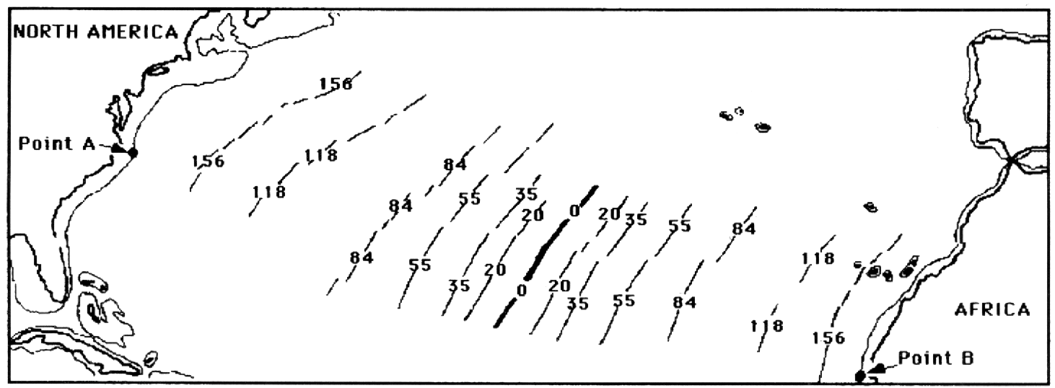
Strip map of a portion of the North Atlantic region showing the coastlines and continental shelf edges of North America and Africa. The bold line labeled "0" is the Mid-Atlantic Ridge. Selected strips of sea floor basalt on either side of the ridge are labeled with their ages in millions of years. The approximate distance between Point A and Point B is 4550 kilometer.

