CP Earth Science
Southern California Plate Tectonics Lab

INTRODUCTION:
The Pacific ocean plate is headed northwestward toward Alaska. 18 MYA (MYA = million years ago), some coastal pieces of North America were torn off and became attached to the Pacific plate. Between 18 and 6 MYA, the Pacific plate dragged these pieces up coast to the northwest and rotated the Western Transverse Ranges block clockwise. About 6 MYA, Baja California broke off of the North American plate and became attached to the Pacific plate. Since then it has been moving with the Pacific plate, pulling away to the northwest from Mexico and pulling open the Gulf of California.

PURPOSE: Study the movement of the Pacific plate and explain the evidence of the theory.

MATERIALS: (per lab group)

scissors
metric ruler
colored pencils
6 small brads
glue or tape

base puzzle sheet
cutout puzzle sheet

PROCEDURE:
Copy the DATA table.
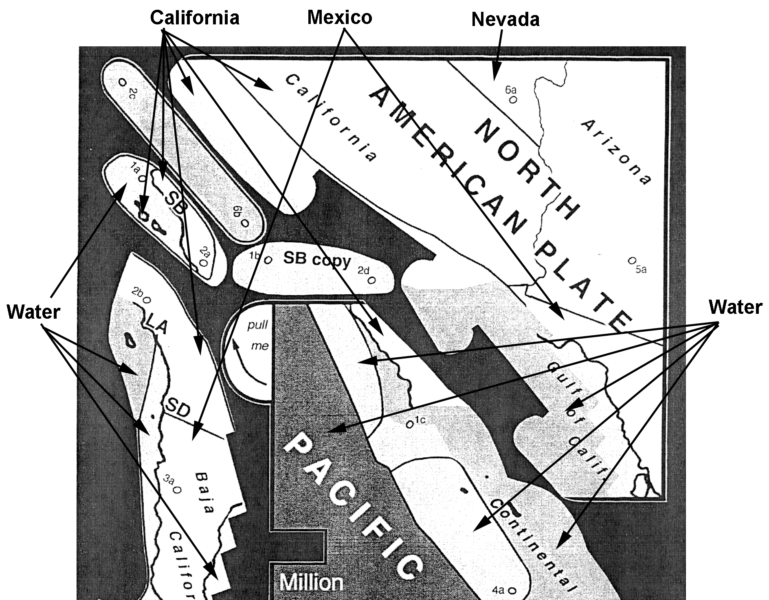
Color each of the states and Mexico shown on the cutout puzzle sheet a different color. Note that there are six areas to color for California, two for Mexico, one for Nevada and one for Arizona. Use a shade of blue to color all of the water areas.
Cut out each of the eight puzzle pieces, removing all of the black background.
Assemble the puzzle as follows.
Poke small round holes in the base sheet in the two pivot circle's (5c and 6c).
Poke round holes in the labeled pivot circles (two holes on each piece).
Feeding the brads in from the front, connect the various pieces in alphabetical order, as follows.
Attach 1a to 1c to 1d and bend the legs out.
Attach 2a to 2b to 2c to 2d and bend the legs out.
Attach 3a to 3b to 3c and bend the legs out.
Attach 4a to 4b and bend the legs out.
Feed the two free lever arms into the fronts of the slots, and then: Attach 5a to 5b to 5c and bend the legs out. Attach 6a to 6b to 6c and bend the legs out. Check to see that the edges of the Baja California piece ended up on top of the edges of the Pacific Plate piece.
Make your puzzle enact this history of breakup and drift, as follows.
Pull the right-hand tab down to its 18 - 6 MYA position (this location is traced on the base sheet). Hold it down there by pressing your right thumb on the tab.
Pull the left-hand tab down until the lower left corner of the Pacific Plate sits on its traced 18 MYA position.
Now, keeping the right tab held down, use the left tab to pull the Pacific around to the northwest. Don't let go of Baja (the right tab) until 6 MYA, then let go and let it be dragged along as well. Stop when the frames of the pieces match up with the frame on the base (0 million years = present day configuration).
As you work the puzzle, observe locations where the puzzle edges are being pulled apart and where edges are running over each other. Compare these observations to a map of topography of the region: Where the plates are being, pulled apart, the Gulf of California, the Salton Sea basin (Imperial Valley) and the offshore borderland basins are being formed. Where the plates are running into each other, the San Bernardino mountains, San Gabriel mountains, Santa Ynez mountains, Santa Monica mountains and the northern Channel Islands are all being pushed up.
Use a metric ruler to measure and record the distance in centimeters Santa Barbara (SB) moves from 18 MYA to 0 MYA.
Measure and record the distance San Diego (SD) moves from 18 MYA to 0 MYA.
Calculate and record the number of centimeters per year that Santa Barbara and San Diego moved from 18 MYA to 0 MYA. (Map scale: 1 cm = 44 km)
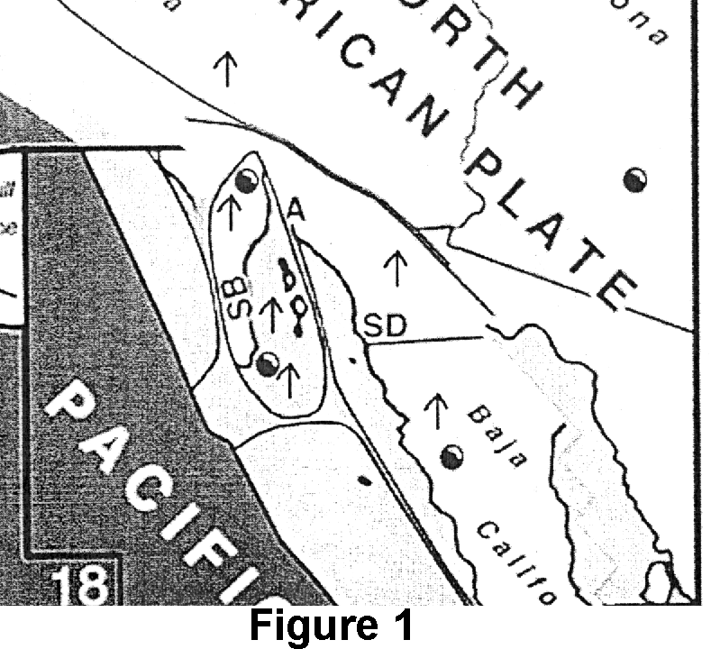
Many rocks, especially lavas, were magnetized when they formed, with their magnetic arrows pointing in the direction of the Earth's north pole at that time. They may keep this old record of the north direction even if they are later moved and turned. With the puzzle in the 18 MYA reconstruction position, draw on some arrows pointing north (see Figure 1). Work the puzzle and see where they end up pointing.

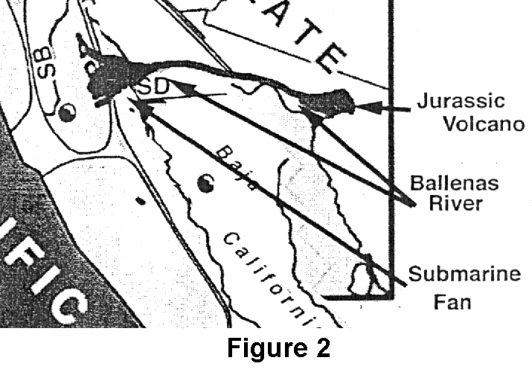
In the Jurassic, 155 million years ago, a volcano near Sonora, northern Mexico, erupted some distinctive purplish-red lavas. In Eocene time, about 40 million years ago, a big river broke up the lavas and carried the volcanic pebbles (called the "Poway clasts") to the coast at San Diego. When the river met the coast it dumped the pebbles into the sea to form a big submarine sedimentary fan. With the puzzle in the 18 MYA reconstruction position, draw on the old Ballenas River path as shown in Figure 2. Then see how the pattern gets torn apart when you work the puzzle.
DATA:
city | Cm (map) | km/18million Yr | km/yr | cm/yr
Santa Barbara
San Diego

DATA ANALYSIS:
Why has Santa Barbara moved further than San Diego during the past 18 million years?
How far (in km) did Los Angeles (LA) move during the past 18 million years?
In which direction would you expect magnetic rocks in western Ventura County to point today?
During what period of time did the northern portion of the Gulf of California form?
Where would you expect the most northern samples of Poway Clasts to be found today?
Where would you expect the most southern samples of Poway Clasts to be found today?

