CP Science 9
Tree Ring Dating Lab

INTRODUCTION:
Trees are some of nature's most accurate timekeepers and provide historical evidence of past climates. Their growth layers, appearing as rings in the cross section of the tree trunk, record evidence of floods, droughts, insect attacks, lightning strikes, and even earthquakes.
Tree growth depends on local conditions, which include the availability of water. Because the water cycle, or hydrologic cycle, is uneven, that is, the amount of water in the environment varies from year to year, scientists use tree-ring patterns to reconstruct regional patterns of drought and climatic change. This field of study is known as dendrochronology.
Trees record climate change. Each year a tree forms a new layer of tissue in the form of a growth ring. The width of each year's ring reflects growing conditions such as moisture or sunlight. A wide ring indicates faster growth (good conditions), whereas a narrow ring indicates slower growth (poor conditions). When the tree is cut down, these rings can be "read" like a diary of the climate. Each year a new tree ring is formed on the outside of the tree. The ring closest to the bark is the youngest and final growth ring. The ring closest to the center of the tree is the oldest growth ring

MATERIALS:
Set of simulated core samples with ring patterns
Scissors
Glue

PROCEDURE:
Copy the data table below.

Imagine you have core samples from four trees.
Sample 1. From a living tree, July 1992 above Ojai.
Sample 2. From a tree from the Ojai Christmas Tree Farm.
Sample 3. From a log found in the woods above Ojai.
Sample 4. From a beam removed from an old log cabin near Ojai.

Carefully cut out the core samples, making sure you know which sample is which.

Look for patterns in the rings. Once a ring pattern has been discovered, line up all the samples. Because you know that Sample 1 was cut in 1992 you can match the patterns of all the other samples and determine:
when all the other trees were cut or cored
the age of each tree
when each tree began to grow
Record this information in your table.

OVER

Make a time line.
Tape the tree ring samples to a piece of notebook paper with the corresponding rings lined up. On the paper, make a time line and label the year number of the earliest year on each tree-ring sample. and the youngest year on each sample.
Label some years that were good growing years as “good” and some years that were poor growing years as “poor”
On your time line, mark other events that might have happened during this time period such as Presidential elections, important discoveries, or record-setting sports achievements. Label at least three events.

DATA:
 | Age of Tree | Year tree was cut | Year growth began
Sample 1
Sample 2
Sample 3
Sample 4

DATA ANALYSIS:
- Which sample was taken from the tree that had lived the longest?
- Which tree had been growing during World War II?
- How do you know which tree ring represents the year one of your parents were born?
- What kind of growing season existed around Ojai during the year of your parents’ birth?
- During which years did droughts occur in Ojai? How do you know?
- Based on the climate information that you observe in the rings, would you say that the overall climate (average) of Ojai is dry, mild, or wet? How did you determine this?
Core samples:

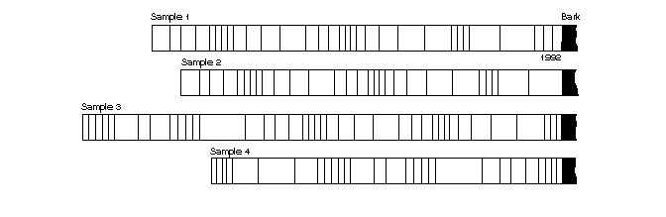

Core samples:

Core samples:

