P2, Physics 12 Worksheet-8 Student Name ______________________
1. The anount of net force required to keep a 5-kg object moving rightward with a constant velocity of 2 m/s is ____.
a. 0 N | b. 0.4 N | c. 2 N | d. 2.5 N | e. 5 N

2. For an object resting upon a non-accelerating surface, the normal force is equal to the weight of the object. T / F (circle one)
3. Which one(s) of the following force diagrams depict an object moving to the right with a constant speed? List all that apply.
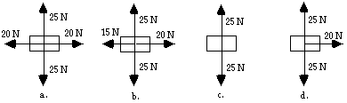
4. According to Newton's third law, every force is accompanied by an equal and opposite reaction force. The reason that these forces do not cancel each other is ____.
a. the action force acts for a longer time period
b. the two forces are not always in the same direction
c. one of the two forces is greater than the other
d. the two forces act upon different objects; only forces on the same object can balance each other.
e. ... nonsense! They do cancel each other. Objects accelerate because of the presence of a third force.
5. For the next several questions, consider the velocity-time plot below for the motion of an object along a horizontal surface. The motion is divided into several time intervals, each labeled with a letter.
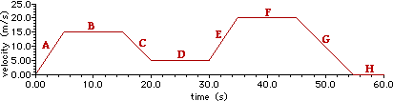
a. During which time interval(s), if any, are there no forces acting upon the object? List all that apply.
b. During which time interval(s), if any, are the forces acting upon the object balanced? List all that apply.
c. During which time interval(s), if any, is there a net force acting upon the object? List all that apply.
d. During which time interval(s), if any, is the net force acting upon the object directed toward the positive direction? List all that apply.
e. During which time interval(s), if any, is the net force acting upon the object directed toward the negative direction? List all that apply.
6. As you sit in your chair and study your physics (presuming that you do), the force of gravity acts downward upon your body. The reaction force to the force of the Earth pulling you downward is ___.
a. the force of the chair pushing you upward
b. the force of the floor pushing your chair upward
c. the force of the Earth pushing you upward
d. the force of air molecules pushing you upwards
e. the force of your body pulling the Earth upwards
f. ... nonsense! Gravity is a field force and there is no such reaction force.

Questions 7–8

A 2 kg block, starting from rest, slides 20 m down a frictionless inclined plane from X to
Y, dropping a vertical distance of 10 m as shown above.

7. The magnitude of the net force on the block while it is sliding is most nearly
(A) 10.1 N (B) 10.4 N (C) 12.5 N (D) 15.0 N (E) 10.0 N

8. The speed of the block at point Y is most nearly
(A) 107 m/s (B) 110 m/s (C) 114 m/s (D) 120 m/s (E) 100 m/s

9. A block of mass 2 kg slides along a horizontal tabletop. A horizontal applied force
of 12 N and a vertical applied force of 15 N act on the block, as shown below. If
the coefficient of kinetic friction between the block and the table is 0.2, the
frictional force exerted on the block is most nearly
(A) 1 N (B) 3 N (C) 4 N (D) 5 N (E) 7 N

